**Midterm Hands-On**

Sample:

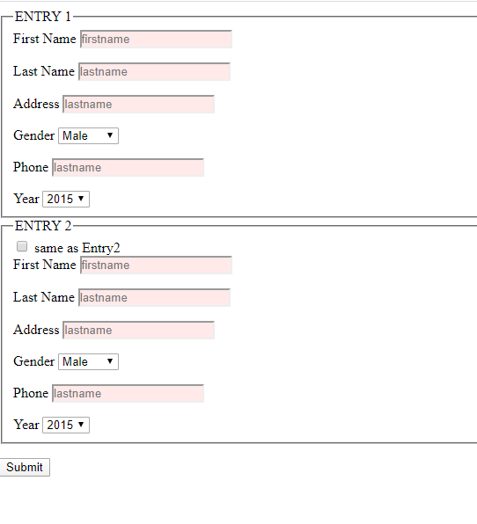

1. create an html and JavaScript file to transfer or copy data from one field to another based on user indicating they should have the same value -  **5marks**

Example: Shipping Address and Billing Address

**Sample:**

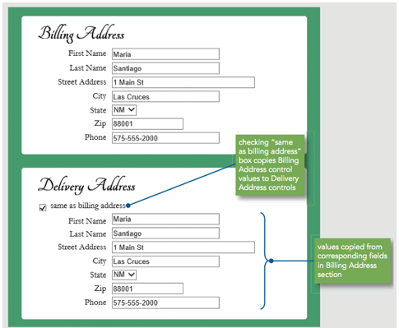

1. Create a custom browser based validation feedback using the following
   1. checkValidity() and setCustomValidity() methods **- 2.5 marks**
   2. CSS :invalid and :valid pseudo-classes **– 5 marks**
2. selectedIndex = -1 **- 5 marks**
3. placeholder **- 2.5 marks**

To change properties of form elements based on validity status.

HINT: refer to power point slide 29 – 31 (ensure you link your CSS and JavaScript file to your html.)

**Sample:**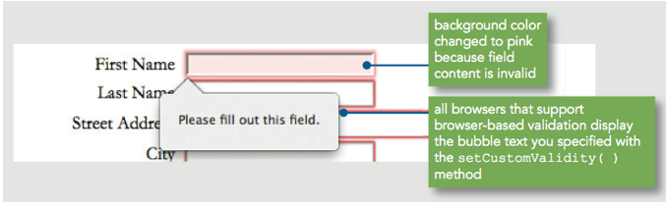

**Ensure all your files are in the same folder. Upload the zip folder into Midterm-Hands-On drop box.**